# Overview

In this exercise you will create a basic Synergy Language program with a data division and procedure division. You will then compile, and run the program.

# Resources

* [Traditional Synergy in Visual Studio - CU Wiki](http://echo.cu.net/cuwiki/Traditional_Synergy_in_Visual_Studio)
* [Traditional Synergy in Visual Studio Common Terminology - CU Wiki](http://echo.cu.net/cuwiki/Traditional_Synergy_in_Visual_Studio_Common_Terminology)
* [Installing Traditional Synergy in Visual Studio Templates - CU Wiki](http://echo.cu.net/cuwiki/Installing_Traditional_Synergy_in_Visual_Studio_Templates)
* [Creating a New DBR Project (TSVS) - CU Wiki](http://echo.cu.net/cuwiki/Creating_a_New_DBR_Project_(TSVS))

# Exercise

For this exercise you should complete the following steps in the order shown:

1. Create a “Training” folder under the “Synergy” folder of your local source tree.
2. Create a “LanguageEssentials” folder under the “Training” folder.
3. Open Synergy\TIMS.ELBs.sln.
4. Add a new [CU – Application (DBR)](http://echo.cu.net/cuwiki/Creating_a_New_DBR_Project_(TSVS)) project “Orders” in \Synergy\Training\LanguageEssentials”.

**Note:**  You will need to search for “Computers Unlimited” in the “Add a new project” dialog:

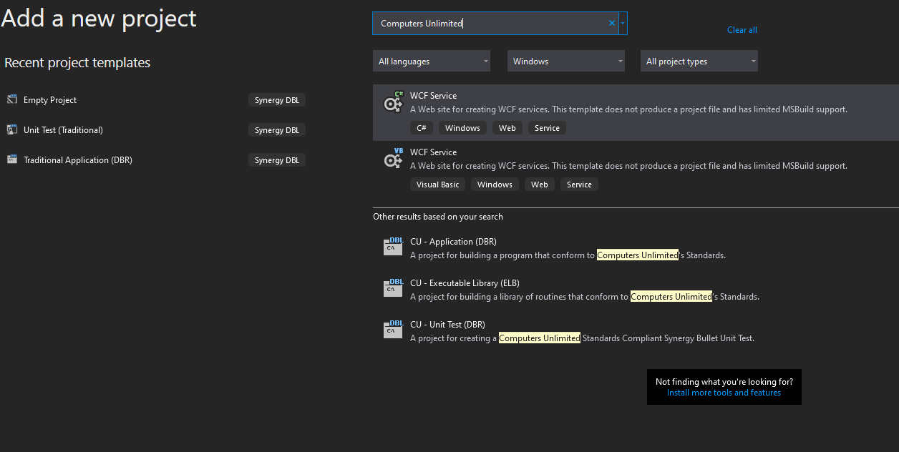

1. Due to current limitations in Visual Studio, the name of the project will always be Program. To work around this you need to select the project and Hit F2 to rename the project.
2. Rename the project to “Orders”.
3. Perform these same steps for the Program.dbv file which was automatically generated for you.
4. Rename the file to “Orders.dbv”.
5. Now open the Project Properties (Hotkey Alt+Enter).
6. Change the Output name under the Application Tab to the name of the new program (Orders).
7. Set Orders as the startup project.
8. In “Orders.dbv” enter the Synergy Language statements to define a basic program structure (data division and procedure division).
9. Include a STOP statement, which defines the “logical” end of the program.
10. Rebuild the solution.
11. Run the program.

# Discussion

At this point, the program doesn’t actually do a great deal (apart from terminate). We will be adding functionality to the program in later exercises.

When you run the program, you should see a %DBR-S-STPMSG, Stop” message, followed by an additional message that describes the program name and line number at which the STOP occurred.